Test Cases: -
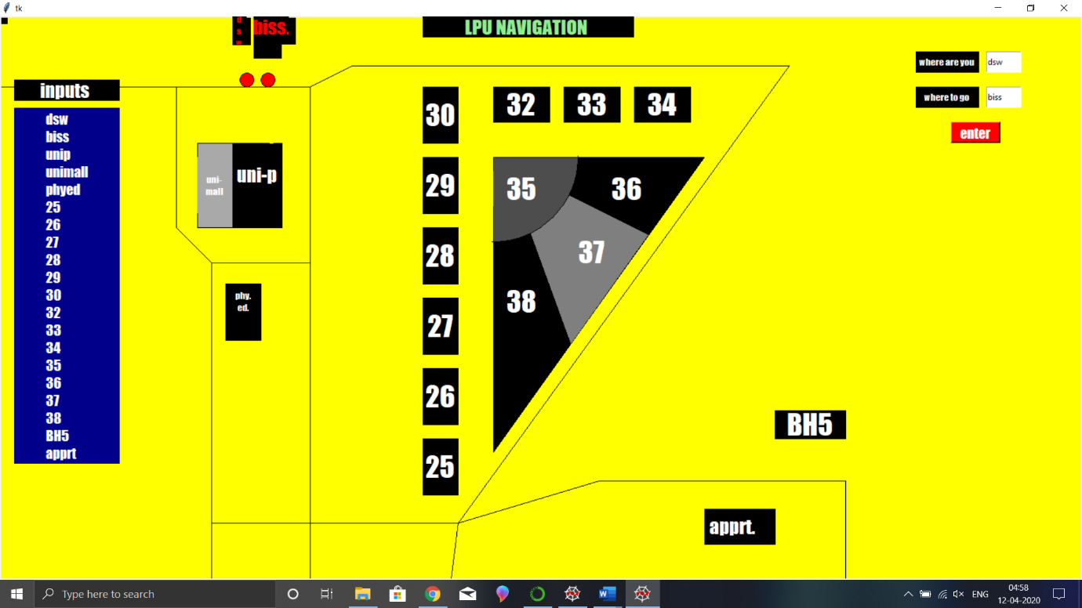
here we can see as the dsw and biss are two blocks and they are neighbours.

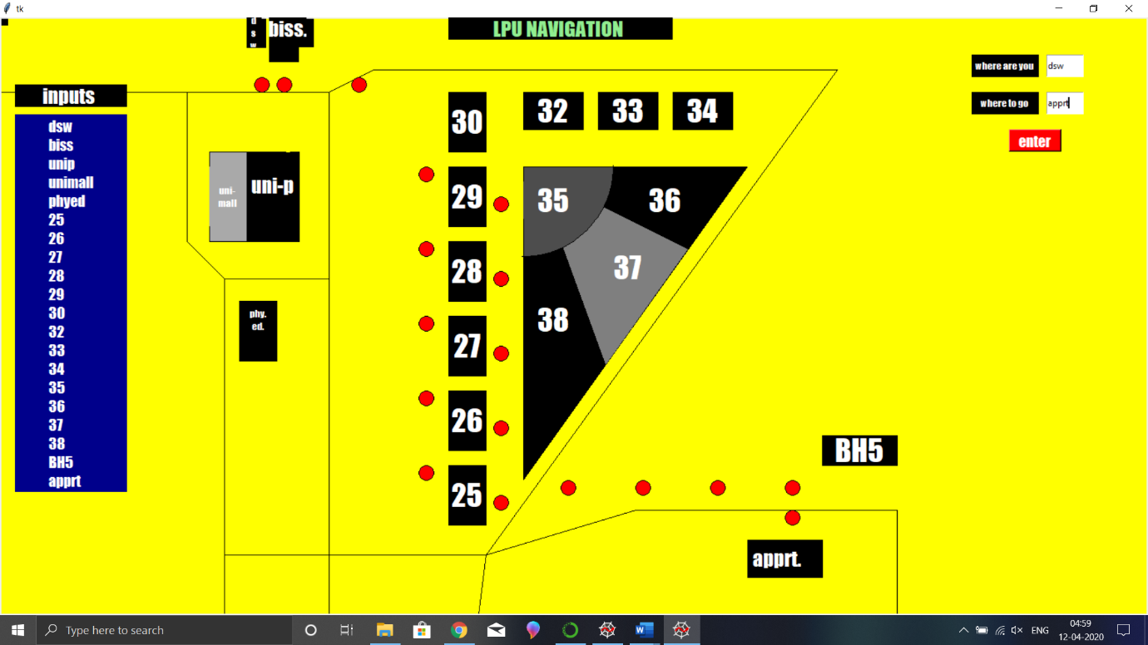
Here we are going from dsw to apprt in between blocks there are two possible ways as showed in the picture.

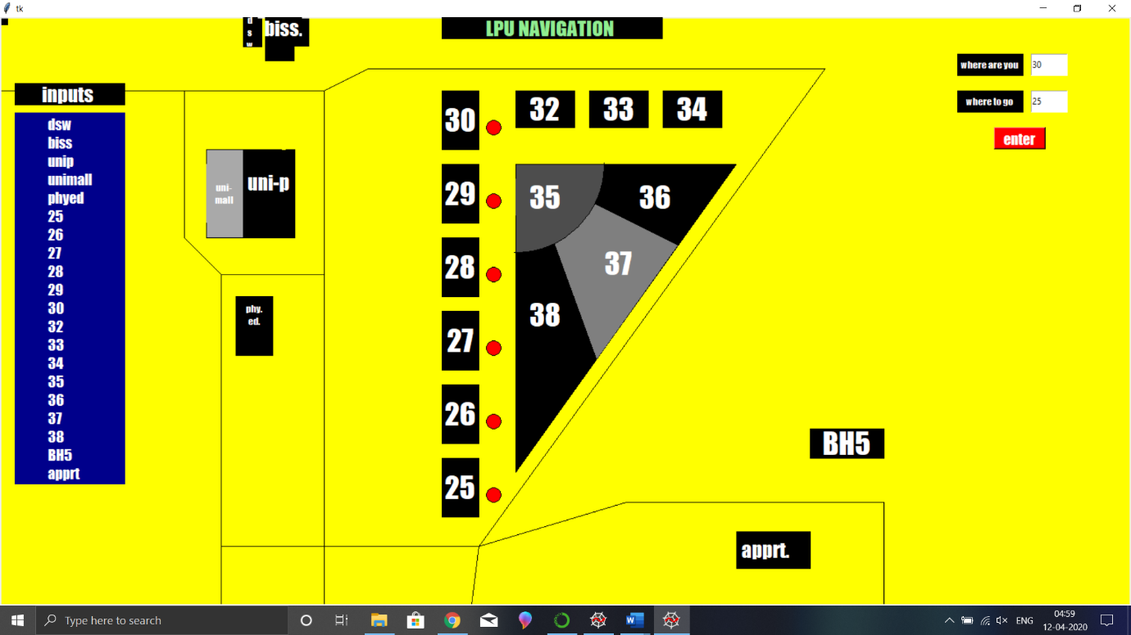
Simple path between block 30 and block 25.

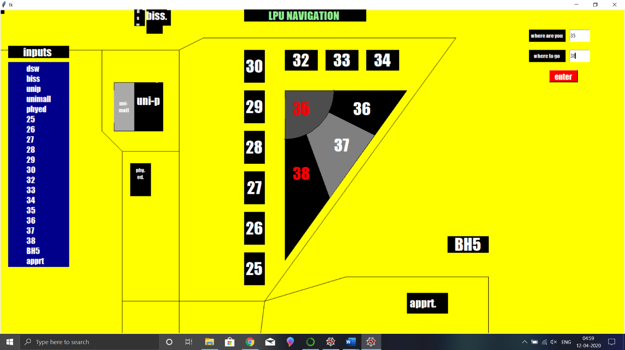
As the paths are from inside the block and there are neighbours also so simply from inside the block we can go to block 38.

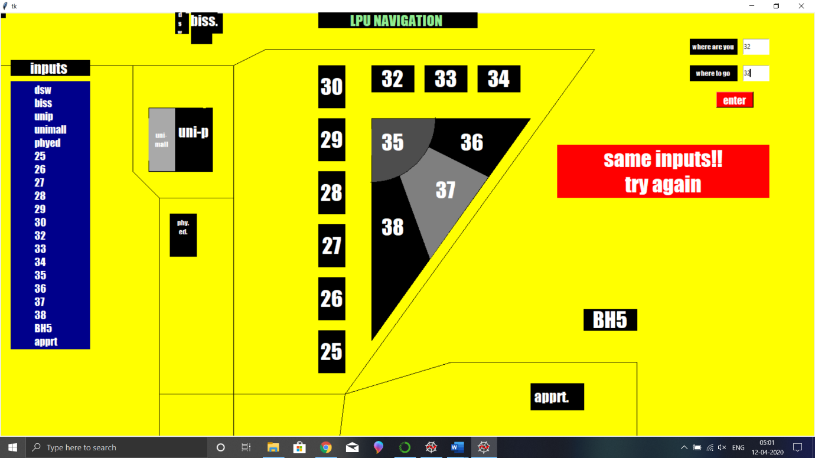
We can see as we input the same data in both fields we get an error which says same input as there is no possible way to go same place where were you standing.

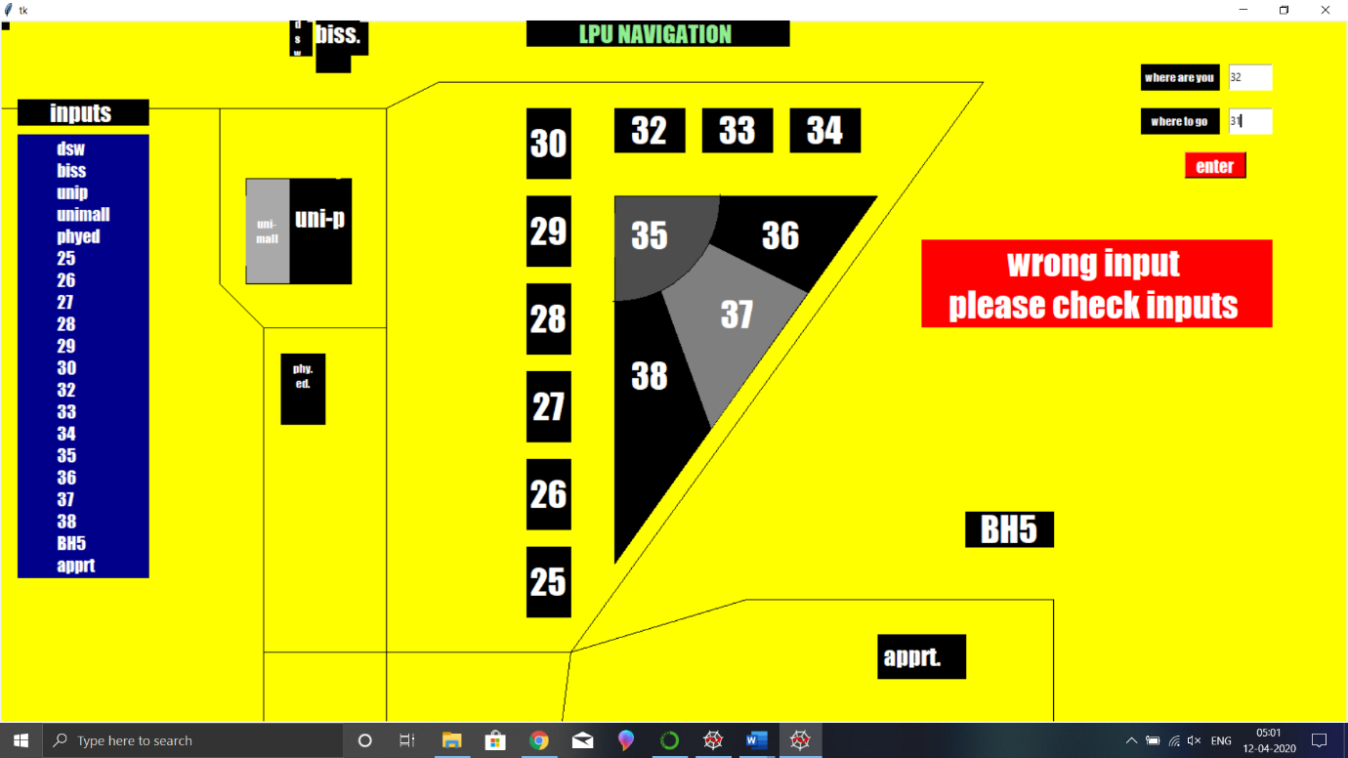
Wrong inputs will display a warning sign, “wrong input please check inputs”.
Input should be as same variable which is given in left side of the screen.

For implementing of Dijkstra algorithm ,there should be weighted graph.
Graph:-
